INSTRUCTIONS FOR PREPARATION OF ABSTRACTS   
LOCATION OF SECOND LINE OF TITLE IF NEEDED

Author One1, Author Two2, and so on

1) Department of …, University of …, City, Country  
2) Department of …, University of …, City, Country

Keywords : max six keywords

Abstract: This is a sample abstract for the Molecular Electronic Structure (MES) conference in Monastir, Tunisia. The preparation instructions are given below.

1. Abstracts should be written in English. The length of each abstract is strictly limited to one page. Abstracts in pdf-format should be submitted online or by email to [ajmi.hammouda@fsm.rnu.tn](mailto:ajmi.hammouda@fsm.rnu.tn%20or%20mes2022-contact@fsm.rnu.tn) before 30th June 2022. Abstracts which are larger than 10 Mb will not be accepted.

2. Abstracts should be in A4 format (210x297 mm, i.e. 8.268x11.693 inches). All text and figures have to fit within side margins of 2.4 cm and top and bottom margins of 2.4 cm. Use the 11 pt Roman font (Roman is the default LaTex font) or a similar font such as Times New Roman throughout the whole Abstract.

3. The title should be typed in all capital letters and centered. If necessary, use a second line, single-spaced just below the first.

4. Leave two lines before the names of the authors and again before the single-spaced affiliations and addresses. In the list of authors, the name of the presenting author should be underlined.

5. After leaving three lines, the body text is typed in a two-column format with a 0.75 cm column spacing. The text should be single-spaced and the first line of each paragraph should be indented 5 spaces.

6. You may put color figures. Note, however, that the abstracts will be printed in black and white.

7. References in the text should be indicated using numbers in brackets [1]. The list of references follows the last line of the text with one extra line inserted. Follow the Style of the American Institute of Physics [1].



Figure 1: Views of Monastir

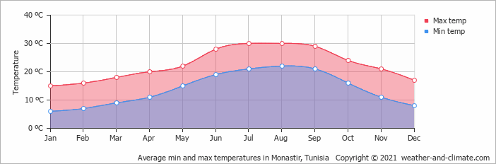

Figure 2: Average minimum and maximum temperatures in Monastir

References

[1] See AIP Style and Notation <http://publish.aps.org/STYLE/> (American Institute of Physics, new York, 1993)